**HOMEWORK WEEK 1**

This week’s homework will be purely Project based **+ small separate independent task (that you’ll need to complete yourself - on page below)**. You need to work as a group and the homework will be submitted by one of the members of your group. List the other members of your group in the document, so that your instructor can mark every student.

**TASK 1 (Project, as a Group)**

1. Your group needs to decide what kind of project you are going to work on and lock in your decision.
2. You need to submit a free style paper that describes your project on a high level. Please cover the following questions:
   1. **What are you building?**
   2. **What does it do or what kind of problem does it solve?**
   3. **What are the key features of your system?**
   4. **Provide a sample architecture diagram of your system** (you can use PPT with squares and circles to demonstrate a simplified flow of your system) For example:
      1. *This doesn’t need to be anything design-based; rather, just an architectural overview of your system (will it be 1-page or multiple? Will they interact with each other? Are you going to store anything? Just a technical perspective instead of a human one to your project).*

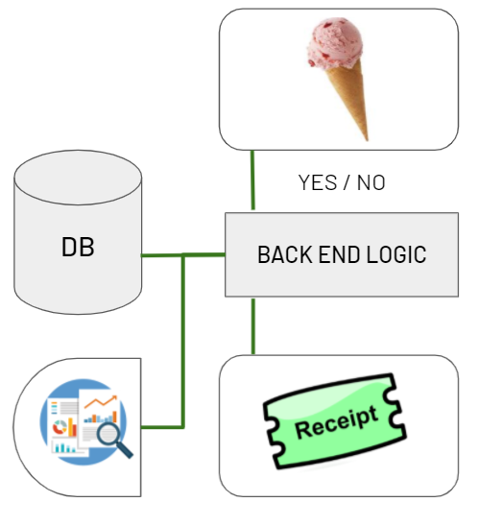

* 1. **Describe the team approach to the project work**: how are you planning to distribute the workload, how are you managing your code, how are you planning to test your system.